**HTML & Website Design**

**Project Group Process Workbook**

**2014**



**Assignment Assessment Overview**

**Each Group should complete the following in relation to the Group work process and submit as part of your project.**

|  |  |
| --- | --- |
| **Group Report and Logbook** | **20%** |
| **Progress Report** – There should be at least 2 progress-report entries posted by each Group | 3% |
| Template 1 – Roles & Responsibilities | See below |
| Template 2 – Understanding the Problem | 1% |
| Template 3 – Exploring Ideas | 2% |
| Template 4 – Group Action Plan | 2% |
| Template 5 – Individual Action Plan | 3% |
| Template 6 – Individual Reflection | 3% |
| Template 7 – Bibliography | 1% |
| Template 8 – Peer Review | 5% |

## Template 1 Roles & Responsibilities

**Roles & Responsabilities**



In order for the group to work effectively it is necessary for members to take responsibility for specific tasks. Assign a group member to each of the roles. If a group member is not performing their role this must be managed within the group. If this cannot be addressed within the group please contact one of your Project lecturers as soon as possible.

|  |  |  |
| --- | --- | --- |
| Role | Responsibility | Team Member |
| Chairperson | Ensures each member remains on task and ensures that all members have a voice | David |
| Time Keeper | Ensures that all tasks are completed on schedule and that meeting time is used appropriately | David |
| Record Keeper | Ensures that all ideas are documented and templates are completed | Luke |

## Template 2 Understanding the Problem



**INTERPRET THE PROBLEM**

Using the headings below, discuss the details of the assignment amongst group members and fill out the template.

|  |
| --- |
| 1. Define the problem. What are you being asked to do? Have you finalised on your subject area for your website?   We are being asked to design a website for a car showroom where people can view the cars on show and decide whether to buy them or not. We have decided to focus on Mercedes cars. |
| 1. List the different XHTML concepts & Web design considerations that will need to be understood in order to complete this assignment.   We will need to understand proper XHTML coding, correct usage of CSS and how to effectively integrate Javascript into the website. |
| 1. What approach will be taken to implement the website e.g. CSS/tables? Explain your reasons for decisions taken.   The website needs to be checked each time some table or a css code is being add up to see if its working, its easier to fix and error if you do it step by step, the error is easier to be spotted than after all of the code being done |
| 1. What has been your Group’s strategy for validating your code? How have you approached this?   We have assessed each others code and ran it through the markup validator on www.w3schools.com |

## Understanding the Problem



**Project requirements**

List the requirements that you have for your website

|  |
| --- |
| 1. What is the overall goal of your website?   The goal of our website is to inform the users of Nolans Garage’s new premises and inform them that it is the top Mercedes dealership in all of Leinster. |
| 1. What are the functional requirements for your site? What will the site **do**?   There will be a counter to show how many times the site was visited. There will be a gallery to show what cars are available to buy and which have already been sold. There will be a registration form so that the user can register with the sites company. |
| 1. What are the non-functional requirements of your site? Do you have a preference for the look and feel of the site?   It will be visually appealing to catch the users attention. Our website will be easy to navigate with a clearly displayed directory on top of each page. All of the information given will be displayed clearly so the user gets what they have come for. |
| 1. What other requirements do you want to achieve in your site?   It will display how many people are online at any given time. It will show the date and time clearly on the main page. The pictures to get into the gallery will raise off the page when the mouse is hovered over them. |

## Template 3 Exploring Ideas

## Exploring ideas – What will the user interface look like?

Discuss possible designs for your website. Once the group decides on a design use Microsoft Word or a Balsamique Mockup to demonstrate the chosen design and layout of website.

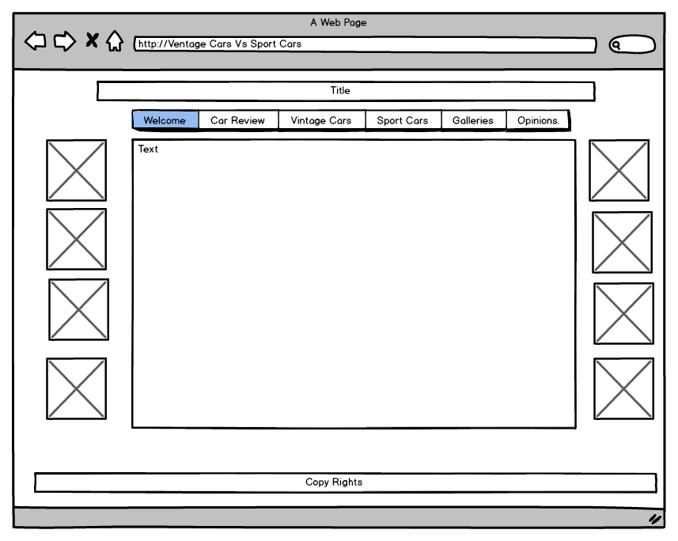

## Exploring Ideas

## Exploring ideas – What will the user interface look like?

**Include Wireframes here**

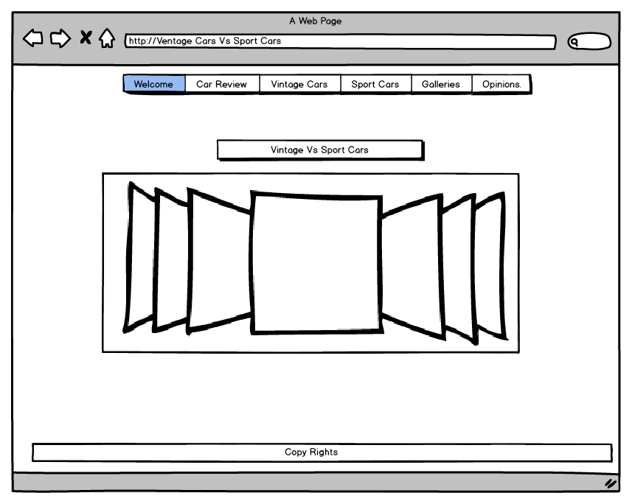**Template 4 Group Action Plan**



**Group Action Plan**

List the tasks your group needs to complete

Assign tasks to each group member and agree on appropriate timelines

**Action Plan:**

|  |  |  |  |
| --- | --- | --- | --- |
| No. | Action | Responsibility | Completed |
| 1 | Css Main Menu | David | yes |
| 2 | Header | Luke | yes |
| 3 | Footer | David | yes |
| 4 | Body Design | All Group | yes |
| 5 | HTML, CSS, JavaScript | All Group | yes |
| 6 | Text added to <h1> <p> | Luke | yes |
| 7 |  |  |  |
| 8 |  |  |  |
| 9 |  |  |  |
| 10 |  |  |  |
|  | | | |

**Template 5 Individual Action Plan**

**Group member 1 should fill in this page**

**Individual Action Plan**

Based on the task(s) assigned to you – record and synopsise your findings under the headings below.

Student Details: David Trojanowski______ Student Number: x14321651____________

1. What task(s) have you been assigned?

Css Menu, Footers/Divs, Body Design and HTML, CSS, JavaScript

1. What information did you find out from your research?

I have learned how to solve problems, write in css, and work with javascript and use a bit of php

1. Explain how this information may be useful in the development of the website.

Basic use off css, html and javascript is needed to structure a website

1. What are you going to feedback to the group?

Im going to help my partner to learn and understand things that I learned through our project.

1. Reference the information you have found.

Css is an simple language but when one line or anything is missing, all of the website might not work correct, I found out that javascript is hard because lots of time it can not do what it has to do and many errors might come out.

**Individual Action Plan**

**Group Member 2 should fill in this page**

**Individual Action Plan**

Based on the task(s) assigned to you – record and synopsise your findings under the headings below.

Student Details: Luke Best________ Student Number:x14548733________

1. What task(s) have you been assigned?

Putting the content on the website e.g. text and pictures

1. What information did you find out from your research?

There are many different ways to structure a website

1. Explain how this information may be useful in the development of the website.

It makes your web design more diverse

1. What are you going to feedback to the group?

I am going to show my partner the importance that the content makes to the overall design of the website.

1. Reference the information you have found.

Finding the information for the content was easy enough but took a lot of time, I used Wikipedia as my main source. I found all of the pictures I used through Google Images.

## Template 6 Reflection

**Group Member 1 should fill in this page**

**REFLECTION**

It is important for the group to reflect on how they arrived at the solution and the solution itself and to identify what could be improved on next time. (Students should complete about 500 words reflection)

Student Details: Dawid Trojanowski_______ Student Number : x14321651__________

1. Overall what has the experience been like working as part of a project team?

The biggest problem is to find an time to meet up like it was with my project partner because we live far away from each other, when we meet up in college we got through a lot of work in few minutes or hours when we had time.

1. What have been the most positive parts?

Doing javascript because it gave us the hardest time, both of us found javascript a bit hard and we had to spend a lot of time on it, even though javascript was the hardest, it was the biggest fun because of satisfy that we had after it when it has start working for us without any troubles

1. What could be improved on next time?

Im pretty much happy about what we did in the project, but next time the group would have to focus more on texting and talking to each other to get through things much faster and easier, dividing the tasks more equally and we would have to manage the time much better. During the process we had days that we done a lot and other days that we didn’t do much, next time we would have to put an time to what we have to get done like get a deadline to our task that we have still to do.

## Template 6 Reflection

**Group Member 2 should fill in this page**

**REFLECTION**

It is important for the group to reflect on how they arrived at the solution and the solution itself and to identify what could be improved on next time. (Students should complete about 500 words reflection)

Student Details: Luke Best________________ Student Number : x14548733_________________

1. Overall what has the experience been like working as part of a project team?

I found it hard to work on the project with my partner as we live in different counties. This made it difficult to communicate properly what Ideas we both had. When we did meet up we used our time efficiently to further the progress of the project.

1. What have been the most positive parts?

For me the most positive part was getting the information across clearly enough so that the user knows exactly what this website is about. Gathering all of the information helped me understand what the site needs and relaying that to my partner to try and accommodate it.

1. What could be improved on next time?

We could use our time more efficiently by meeting up more often and communicating better, this would take off a lot of pressure and go towards a better finished website. We could also split the work more evenly so we both get experience in each side of the web design process.

## Template 7 Bibliography

**Referencing**

You must reference any books, articles, or web pages which you used to create your web pages. This might include content for your site or resources on how to use a piece of JavaScript code. You must use the **Harvard Referencing Style**. There are resources on moodle to help you with this style.

<http://freehostedscripts.net/> how many online, date and time

<http://www.w3schools.com/> basic code

<http://www.javascriptfreecode.com/> view counter, raised pictures

<http://en.wikipedia.org/wiki/Mercedes-Benz> site content

<https://www.youtube.com/> Mercedes adverts

## Template 8 Peer Review

**PEER REVIEW**

When all group members contribute equally it makes sense for everyone to get the same result. However, if group members do not contribute evenly it is only fair that each group member receives the mark that truly reflects their contribution.

Each group member can earn a maximum of 10 marks for their contribution. Group members who made little or no contribution will receive fewer marks. The group must collectively rate each member’s contribution in the grid below by writing the member’s name in the box the group feels is most appropriate.

|  |  |  |  |
| --- | --- | --- | --- |
| **Main Contributor(s)**  **3D smiley 1**  **10 marks** | **Secondary Contributor(s)**  3D smiley 5  **7 marks** | **Minimal Contribution**  3D smiley 3  **3 marks** | **No Contribution**  [Picture]  **0 marks in Assignment** |
| David  Luke |  |  |  |

I ______________________________ agree with the marks that have been awarded for my contribution to the assignment.

I ______________________________ agree with the marks that have been awarded for my contribution to the assignment.